Sets

🔢 Definition of a Set
# Source: AI Source: Provided by: [Data Path: Persons Table -> ID Column: 1, Name_En Column: Motasem Essam] -> From: [ChatGPT] on [7/7/2026]
🌟 What is a Set?
A set is a well-defined collection of distinct objects, called elements or members.
- Well-defined means it is always clear whether an object belongs to the set.
- Distinct means duplicate elements are not counted more than once.
Examples
A = {1, 2, 3, 4}

B = {Apple, Banana, Orange}
C = {Red, Green, Blue}
Not a Set
The collection of beautiful paintings.
This is not a set because "beautiful" is subjective.

what mean by subjective here
# Source: AI Source: Provided by: [Data Path: Persons Table -> ID Column: 1, Name_En Column: Motasem Essam] -> From: [ChatGPT] on [7/7/2026]
Here, subjective means based on personal opinions, feelings, or tastes rather than an objective rule.
Example
Consider the collection:
"The collection of beautiful paintings."
The problem is the word beautiful.
Different people may disagree:
- 👩 Person A thinks Painting X is beautiful.
- 👨 Person B thinks Painting X is not beautiful.
- 👩‍🎨 Person C thinks Painting Y is the most beautiful.
There is no single mathematical rule that determines whether a painting is "beautiful."
Because membership is unclear, this collection cannot be considered a mathematical set.

Objective vs. Subjective
# Source: AI Source: Provided by: [Data Path: Persons Table -> ID Column: 1, Name_En Column: Motasem Essam] -> From: [ChatGPT] on [7/7/2026]
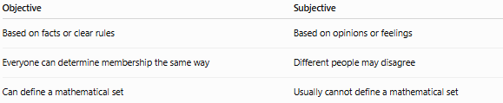
Objective | Subjective
Based on facts or clear rules | Based on opinions or feelings
Everyone can determine membership the same way | Different people may disagree
Can define a mathematical set | Usually cannot define a mathematical set

✅ Objective Example
# Source: AI Source: Provided by: [Data Path: Persons Table -> ID Column: 1, Name_En Column: Motasem Essam] -> From: [ChatGPT] on [7/7/2026]
The set of even numbers less than 10.
Everyone agrees the elements are:
{2, 4, 6, 8}

❌ Subjective Example
# Source: AI Source: Provided by: [Data Path: Persons Table -> ID Column: 1, Name_En Column: Motasem Essam] -> From: [ChatGPT] on [7/7/2026]
The set of delicious foods.
One person might include:
{Pizza, Sushi, Ice Cream}
Another person might include:
{Salad, Curry, Apples}
There is no universal agreement on what is "delicious."

More Examples
# Source: AI Source: Provided by: [Data Path: Persons Table -> ID Column: 1, Name_En Column: Motasem Essam] -> From: [ChatGPT] on [7/7/2026]
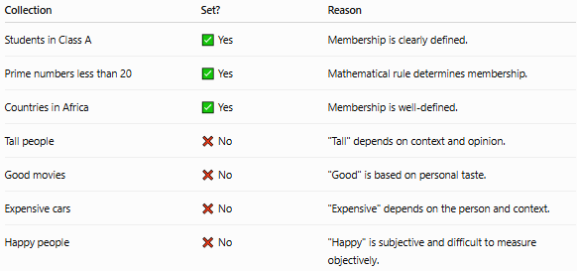
Collection | Set? | Reason
Students in Class A | ✅ Yes | Membership is clearly defined.
Prime numbers less than 20 | ✅ Yes | Mathematical rule determines membership.
Countries in Africa | ✅ Yes | Membership is well-defined.
Tall people | ❌ No | "Tall" depends on context and opinion.
Good movies | ❌ No | "Good" is based on personal taste.
Expensive cars | ❌ No | "Expensive" depends on the person and context.
Happy people | ❌ No | "Happy" is subjective and difficult to measure objectively.

🔢 Set Rules
# Source: AI Source: Provided by: [Data Path: Persons Table -> ID Column: 1, Name_En Column: Motasem Essam] -> From: [ChatGPT] on [7/7/2026]
A valid set follows these basic rules:

Rule 1: Well-defined
# Source: AI Source: Provided by: [Data Path: Persons Table -> ID Column: 1, Name_En Column: Motasem Essam] -> From: [ChatGPT] on [7/7/2026]
Every object must clearly belong or not belong

Which mean, it must be possible to answer "Is this object in the set?" with a clear Yes or No.
- "Even numbers less than 10" → Clear answer → ✅ Set
- "Beautiful paintings" → No clear, universal answer → ❌ Not a set
✅ Example
A = {Even numbers less than 10}
❌ Example
A = {Nice movies}

Rule 2: Distinct Elements
# Source: AI Source: Provided by: [Data Path: Persons Table -> ID Column: 1, Name_En Column: Motasem Essam] -> From: [ChatGPT] on [7/7/2026]
Repeated elements appear only once.
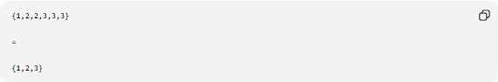
{1,2,2,3,3,3}

=

{1,2,3}

Rule 3: Order Doesn't Matter
# Source: AI Source: Provided by: [Data Path: Persons Table -> ID Column: 1, Name_En Column: Motasem Essam] -> From: [ChatGPT] on [7/7/2026]
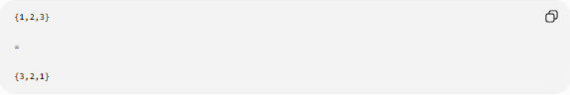
{1,2,3}

=

{3,2,1}
These are the same set.

🔢 Elements Can Be Anything
# Source: AI Source: Provided by: [Data Path: Persons Table -> ID Column: 1, Name_En Column: Motasem Essam] -> From: [ChatGPT] on [7/7/2026]
A set may contain:
- Numbers
- Letters
- Words
- People
- Objects
- Other sets

🔢 Notation and Types of Set Notation

A. Roster (Tabular) Notation
# Source: AI Source: Provided by: [Data Path: Persons Table -> ID Column: 1, Name_En Column: Motasem Essam] -> From: [ChatGPT] on [7/7/2026]
Lists every element inside braces.
Example
A = {2,4,6,8}

Types of Roster Notation
- Finite:
  - The set of vowels in the English alphabet can be written as: {a, e, i, o, u}
  - The set of first five positive integers: {1, 2, 3, 4, 5}
- Infinite:
  - The set of all natural numbers: {1, 2, 3, 4, ...}
  - The set of all even numbers: {2, 4, 6, 8, ...}

B. Set-Builder Notation
# Source: AI Source: Provided by: [Data Path: Persons Table -> ID Column: 1, Name_En Column: Motasem Essam] -> From: [ChatGPT] on [7/7/2026]
Describes a rule for membership.

Structure of Set-Builder Notation
# Source: AI Source: Provided by: [Data Path: Persons Table -> ID Column: 1, Name_En Column: Motasem Essam] -> From: [ChatGPT] on [7/7/2026]
Set-builder notation generally follows this format:
{x ∣ condition on x}
Here's what the components mean:
- {} denotes a set.
- x represents an element in the set.
- | means "such that."
- The condition describes the property that x must satisfy to be included in the set.

Example
# Source: AI Source: Provided by: [Data Path: Persons Table -> ID Column: 1, Name_En Column: Motasem Essam] -> From: [ChatGPT] on [7/7/2026]
A = {x | x is an even number less than 10}
Read as:
"A is the set of all x such that x is an even number less than 10."

Notations and words used in Set-builder notation

1. Vertical Bar (|) or Colon (:)
# Source: AI Source: Provided by: [Data Path: Persons Table -> ID Column: 1, Name_En Column: Motasem Essam] -> From: [ChatGPT] on [7/7/2026]
- Symbol: ∣ or :
- Meaning: "such that" or "where."
- Usage: Specifies the condition or property that the elements of the set must satisfy.
- Example:
{x∈R∣x>0} or {x∈R:x>0}
This set contains all real numbers x such that x>0, i.e., the set of positive real numbers.

2. Universal Quantifier (∀)
# Source: AI Source: Provided by: [Data Path: Persons Table -> ID Column: 1, Name_En Column: Motasem Essam] -> From: [ChatGPT] on [7/7/2026]
- Notation: ∀x∈S, condition
- Meaning: "For all x in set S, the condition holds."
- Example: ∀x∈R,x²≥0 means "For all real numbers x, x² is greater than or equal to zero."

3. Existential Quantifier (∃)
# Source: AI Source: Provided by: [Data Path: Persons Table -> ID Column: 1, Name_En Column: Motasem Essam] -> From: [ChatGPT] on [7/7/2026]
- Notation: ∃x∈S, condition
- Meaning: "There exists an x in set S such that the condition holds."
- Example: ∃x∈Z,x²=4 means "There exists an integer x such that x²=4."

4. Set Membership and Inclusion Symbols
# Source: AI Source: Provided by: [Data Path: Persons Table -> ID Column: 1, Name_En Column: Motasem Essam] -> From: [ChatGPT] on [7/7/2026]
- Notation:
- Membership Symbol x∈S,
- Not in Symbol x∉S
- Subset Symbol (⊆)
- Proper Subset A⊂B
- Superset A⊇B
- Proper Superset A⊃B
- Example:
- {x∈Z:x2=4} means "The set of all integers x such that x²=4."
- {x∈R:x∉Z} means "The set of all real numbers x that are not integers."
- {x∈N:x≤10}⊆N means "The set of natural numbers x such that x is less than or equal to 10 is a subset of natural numbers."
- {x∈N:x<5}⊂N means "The set of natural numbers less than 5 is a proper subset of the natural numbers."
- {1,2,3,4}⊇{2,3} means "The set {1,2,3,4} is a superset of {2,3}."
- {1,2,3}⊃{1,2} means "The set {1,2,3} is a proper superset of {1,2}."

5. Set Types Symbols
# Source: AI Source: Provided by: [Data Path: Persons Table -> ID Column: 1, Name_En Column: Motasem Essam] -> From: [ChatGPT] on [7/7/2026]
- Notation:
- Empty Set ∅
- Singleton Set a
- Universal Set (U)
- Finite Set {a,...,z}
- Infinite Set N, Z, R, C
- Interval Set >, <, ≥, ≤
- Power Set (A)
- Example:
- {x:x<0 and x>0} = ∅ is the empty set because no number satisfies both conditions.
- {x:x=5} This represents the set containing only the element 5, i.e., {5}.
- {x:x∈{1,2,3}} means "The set of all x such that x is in the set {1,2,3}." This set is finite with three elements: 1,2,3.
- {x:x∈N}} represents "The set of all natural numbers." This is an infinite set.
- {x:0≤x≤5} represents the set of all real numbers between 0 and 5, inclusive.
- P(A)={B:B⊆A}.

6. Union (∪) and Intersection (∩)
# Source: AI Source: Provided by: [Data Path: Persons Table -> ID Column: 1, Name_En Column: Motasem Essam] -> From: [ChatGPT] on [7/7/2026]
- Notation: A∪B, A∩B
- Meaning: The union and intersection of sets, respectively.
- Example: {x∈A∩B∣x∈A and x∈B}, {x∈A∪B∣x∈A or x∈B}

7-Cartesian Product (Set of Ordered Pairs)
# Source: AI Source: Provided by: [Data Path: Persons Table -> ID Column: 1, Name_En Column: Motasem Essam] -> From: [ChatGPT] on [7/7/2026]
- Notation: A×B
- Meaning: Cartesian Product.
- Example: ∅={(a,b)∈A×B∣a∈A and b∈B and a>5 and b<0}

Notes
- The notation N×N is the set of all ordered pairs (x,y), where both x and y are natural numbers. In other words:
R×R={(x,y)∣x∈N and y∈N}
- The notation Z×Z is the set of all ordered pairs (x,y), where both x and y are integer numbers. In other words:
Z×Z={(x,y)∣x∈Z and y∈Z}
- The notation R×R is the set of all ordered pairs (x,y), where both x and y are real numbers. In other words:
R×R={(x,y)∣x∈R and y∈R}
- The notation N×R is the set of all ordered pairs (x,y), where x is natural number and y is real numbers. In other words:
N×R={(n,r)∣n∈N,r∈R}

8. Set of Ordered Pairs
# Source: AI Source: Provided by: [Data Path: Persons Table -> ID Column: 1, Name_En Column: Motasem Essam] -> From: [ChatGPT] on [7/7/2026]
- Notation: {(x,y):condition}
- Meaning: A set of ordered pairs satisfying a condition.
- Example: {(x,y):x>y and x,y∈Z} represents the set of ordered pairs of integers where x>y.

9. Set of Solutions to an Equation or Inequality
# Source: AI Source: Provided by: [Data Path: Persons Table -> ID Column: 1, Name_En Column: Motasem Essam] -> From: [ChatGPT] on [7/7/2026]
- Notation: {x,:Equation}, {x,:Inequality}
- Meaning: A set containing all values that satisfy a given equation or inequality
- Example:
- {x:x2−4=0} represents the set of solutions to the equation x²−4=0, which is {2,−2}.
- {x:x∈R,x>3} represents the set of real numbers greater than 3.

10. Set of Functions
# Source: AI Source: Provided by: [Data Path: Persons Table -> ID Column: 1, Name_En Column: Motasem Essam] -> From: [ChatGPT] on [7/7/2026]
- Notation: f
- Meaning: A set containing functions that satisfy specific conditions.
- Example:
- {f:f is a continuous function on [0,1]} represents the set of all continuous functions on the interval [0,1].
- {f:f(x)=x² for all x∈R} represents the set of all functions where f(x)=x².
- {f∣f:R→R,f(−x)=−f(x) for all x∈R} represents the set contains all functions that are odd, meaning their graphs have rotational symmetry about the origin.

Notes 1
The notation f:R→R means that f is a function where:
- The domain (set of inputs) is R, which is the set of real numbers.
- The codomain (set of possible outputs) is also R, the set of real numbers.
In other words, f takes a real number as input and gives a real number as output.

Notes 2
- how can read this {f:f(x)=x² for all x∈R}
"The set of all functions f such that f(x)=x² for all x in R."
- how can read this {f∣f:R→R,f(−x)=−f(x) for all x∈R}
"The set of all functions f such that f is a function from the real numbers to the real numbers (f:R→R), and for all real numbers x, the function satisfies the condition f(−x)=−f(x)."

11-Other words
# Source: AI Source: Provided by: [Data Path: Persons Table -> ID Column: 1, Name_En Column: Motasem Essam] -> From: [ChatGPT] on [7/7/2026]
- Words:
- Primes
- Even
- Odd Numbers
- Divides
- Divisors
- Multiples
- Example:
- {x:x∈N,x is prime}
- {x:x∈Z,x is even} represents the set of all even integers {…,−4,−2,0,2,4,…}.
- {x:x∈Z,x is odd} represents the set of all odd integers: {…,−3,−1,1,3,… }.
- {x:x∈N,x divides 12} represents the set of divisors of 12, which is {1,2,3,4,6,12}.
- {x:x∈N, x is a divisor of 12} represents the set of divisors of 12, which is {1,2,3,4,6,12}.
- {x:x∈N,x is a multiple of 5} represents the set of multiples of 5, i.e., {5,10,15,20,… }.

Using Set-Builder Notation to Define Other Set-Builder Notations
# Source: AI Source: Provided by: [Data Path: Persons Table -> ID Column: 1, Name_En Column: Motasem Essam] -> From: [ChatGPT] on [7/7/2026]
set-builder notation can be used to define other sets that involve set-builder notation as part of their definition. In fact, it is a common practice to use one set-builder notation inside another, creating complex sets or defining sets of sets.

Examples of Using Set-Builder Notation to Define Other Set-Builder Notations

1. Defining a Set of Sets (Meta-Set)
# Source: AI Source: Provided by: [Data Path: Persons Table -> ID Column: 1, Name_En Column: Motasem Essam] -> From: [ChatGPT] on [7/7/2026]
You can use set-builder notation to define a set that contains other sets as elements.
Example:
{A:A⊆N and A has at least 3 elements}
This defines a set of sets A, where each A is a subset of the natural numbers N, and each subset must have at least 3 elements. Here, the set-builder notation inside is used to define the elements of the outer set, which are themselves sets.

2. Defining a Set of Functions (Using Set-Builder Inside Set-Builder)
# Source: AI Source: Provided by: [Data Path: Persons Table -> ID Column: 1, Name_En Column: Motasem Essam] -> From: [ChatGPT] on [7/7/2026]
You can define a set of functions using set-builder notation and use another set-builder notation to specify conditions on those functions.
Example:
{f:f:R→R and {x:f(x)≥0}=R}
This defines the set of all functions f from R to R such that the set of all x for which f(x)≥0 is equal to the entire real number set R. Here, the inner set-builder notation defines the set of x values that satisfy the inequality.

3. Set of Solutions to Equations Involving Sets
# Source: AI Source: Provided by: [Data Path: Persons Table -> ID Column: 1, Name_En Column: Motasem Essam] -> From: [ChatGPT] on [7/7/2026]
You can use set-builder notation to describe the set of solutions to an equation, where the condition itself involves other sets.
Example:
{A:A⊆Z and ∃x∈A such that x2=9}
This defines the set of all subsets A of integers Z where there exists at least one element x in A such that x²=9. The condition inside the set-builder notation (∃x∈A) uses another set-builder notation to define the elements that satisfy the equation x²=9.

4. Defining a Set of Pairs Using Set-Builder Notation
# Source: AI Source: Provided by: [Data Path: Persons Table -> ID Column: 1, Name_En Column: Motasem Essam] -> From: [ChatGPT] on [7/7/2026]
You can define a set of ordered pairs, where each pair itself is described by a condition involving another set.
Example:
{(x,y):x∈Z and y∈{z:z∈R,z2=x}}
This defines the set of ordered pairs (x,y) such that x is an integer, and y belongs to the set of all real numbers z such that z²=x. Here, the set-builder notation inside the larger set describes the possible values for y based on the condition involving x.
How It Works
Nested Set-builder Notation: You can embed one set-builder notation inside another. The inner set-builder notation specifies the conditions for elements (sets, functions, or other objects) that are then used as elements of the outer set.

Condition-Defining: Just like how you use set-builder notation to define a set based on some property (e.g., {x:x>0}, you can apply the same approach to define complex structures, such as sets of sets, sets of functions, or sets of relations.

How It Works
# Source: AI Source: Provided by: [Data Path: Persons Table -> ID Column: 1, Name_En Column: Motasem Essam] -> From: [ChatGPT] on [7/7/2026]
Nested Set-builder Notation: You can embed one set-builder notation inside another. The inner set-builder notation specifies the conditions for elements (sets, functions, or other objects) that are then used as elements of the outer set.

Condition-Defining: Just like how you use set-builder notation to define a set based on some property (e.g., {x:x>0}, you can apply the same approach to define complex structures, such as sets of sets, sets of functions, or sets of relations.

C. Descriptive Notation
# Source: AI Source: Provided by: [Data Path: Persons Table -> ID Column: 1, Name_En Column: Motasem Essam] -> From: [ChatGPT] on [7/7/2026]
Describes the set using words.
Example
A = The set of vowels in the English alphabet.

Converting between Roster notation and Set-builder notation

1-From Roster notation to Set-builder notation
# Source: AI Source: Provided by: [Data Path: Persons Table -> ID Column: 1, Name_En Column: Motasem Essam] -> From: [ChatGPT] on [7/7/2026]
Steps:
- Identify the Pattern: Look for a common property or pattern among the elements.
- Express the Property: Use a condition or rule to describe the elements.
Example Set:
{2,4,6,8,10}
Conversion:
{2,4,6,8,10}→{x∣x is an even number between 1 and 11}

2-From Description Method to Listing Method
# Source: AI Source: Provided by: [Data Path: Persons Table -> ID Column: 1, Name_En Column: Motasem Essam] -> From: [ChatGPT] on [7/7/2026]
Steps:
- Identify the Rule: Understand the condition or rule that defines the set.
- List the Elements: List all elements that satisfy the condition.
Example Set:
{x∣x is a prime number less than 12}
Conversion:
{x∣x is a prime number less than 12}→{2,3,5,7,11}

Comparison
# Source: AI Source: Provided by: [Data Path: Persons Table -> ID Column: 1, Name_En Column: Motasem Essam] -> From: [ChatGPT] on [7/7/2026]
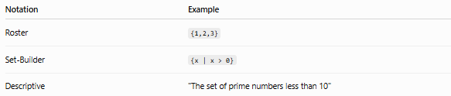
Notation | Example
Roster | {1,2,3}
Set-Builder | {x | x > 0}
Descriptive | "The set of prime numbers less than 10"

📦 Classifying Methods of Set Definition
# Source: AI Source: Provided by: [Data Path: Persons Table -> ID Column: 1, Name_En Column: Motasem Essam] -> From: [ChatGPT] on [7/7/2026]
These are the three main methods of defining a set in set theory.

📦 Classifying Methods of Set Definition
# Source: AI Source: Provided by: [Data Path: Persons Table -> ID Column: 1, Name_En Column: Motasem Essam] -> From: [ChatGPT] on [7/7/2026]
A set can be defined in three common ways:
- Intensional Definition
- Extensional Definition
- Ostensive Definition

1. 📝 Intensional Definition (Rule-Based Definition)
# Source: AI Source: Provided by: [Data Path: Persons Table -> ID Column: 1, Name_En Column: Motasem Essam] -> From: [ChatGPT] on [7/7/2026]
🌟 Definition
An intensional definition defines a set by stating a rule, property, or condition that every element must satisfy.
Instead of listing every element, it describes how to determine whether an object belongs to the set.

Characteristics
- Uses a rule or condition
- Suitable for finite and infinite sets
- Closely related to set-builder notation

Examples
Example 1
A = {x | x is an even number less than 10}
Result:
A = {2,4,6,8}

Example 2
B = {x | x is a prime number}
This defines an infinite set without listing every prime number.

Example 3
C = {x | x > 100}
Every number greater than 100 belongs to the set.

Advantages
- Easy to define large or infinite sets
- Compact and precise
- Common in mathematics

2. 📋 Extensional Definition (Listing Definition)
# Source: AI Source: Provided by: [Data Path: Persons Table -> ID Column: 1, Name_En Column: Motasem Essam] -> From: [ChatGPT] on [7/7/2026]
🌟 Definition
An extensional definition defines a set by listing every element explicitly.
It is also called an enumerative definition or roster definition.

Characteristics
- Lists all elements
- Best for small finite sets
- Uses roster notation

Examples
Example 1
A = {2,4,6,8}

Example 2
Vowels = {A,E,I,O,U}

Example 3
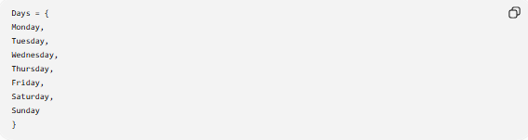
Days = {
Monday,
Tuesday,
Wednesday,
Thursday,
Friday,
Saturday,
Sunday
}

Advantages
- Very easy to read
- No interpretation needed
- Exact membership

3. 👀 Ostensive Definition (Definition by Examples)
# Source: AI Source: Provided by: [Data Path: Persons Table -> ID Column: 1, Name_En Column: Motasem Essam] -> From: [ChatGPT] on [7/7/2026]
🌟 Definition
An ostensive definition defines a set by showing representative examples of its elements instead of giving a complete list or a formal rule.
The examples help the reader understand what kinds of objects belong to the set.

Characteristics
- Uses examples
- Often incomplete
- Common in teaching
- May use an ellipsis (...) to indicate continuation

Examples
Example 1
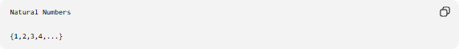
Natural Numbers

{1,2,3,4,...}
The ellipsis (...) indicates the pattern continues.

Example 2
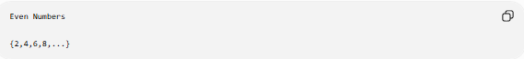
Even Numbers

{2,4,6,8,...}

Example 3
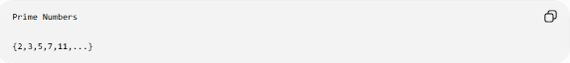
Prime Numbers

{2,3,5,7,11,...}

Advantages
- Easy to understand
- Quickly illustrates a pattern
- Useful for infinite sets

Comparison
# Source: AI Source: Provided by: [Data Path: Persons Table -> ID Column: 1, Name_En Column: Motasem Essam] -> From: [ChatGPT] on [7/7/2026]
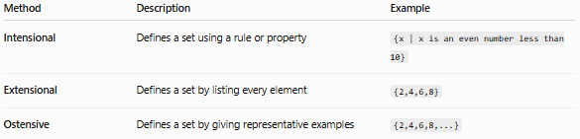
Method | Description | Example
Intensional | Defines a set using a rule or property | {x | x is an even number less than 10}
Extensional | Defines a set by listing every element | {2,4,6,8}
Ostensive | Defines a set by giving representative examples | {2,4,6,8,...}

Relationship to Set Notation
# Source: AI Source: Provided by: [Data Path: Persons Table -> ID Column: 1, Name_En Column: Motasem Essam] -> From: [ChatGPT] on [7/7/2026]
These methods are closely related to the notations you may already know:
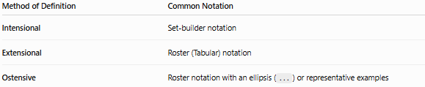
Method of Definition | Common Notation
Intensional | Set-builder notation
Extensional | Roster (Tabular) notation
Ostensive | Roster notation with an ellipsis (...) or representative examples

🧠 Simple Analogy
# Source: AI Source: Provided by: [Data Path: Persons Table -> ID Column: 1, Name_En Column: Motasem Essam] -> From: [ChatGPT] on [7/7/2026]
Imagine defining the students in a school.
📝 Intensional (Rule)
"All students enrolled in Grade 10."
You describe the rule for membership.

📋 Extensional (Listing)
{Ali, Sara, Omar, Fatima}
You list every student.

👀 Ostensive (Examples)
{Ali, Sara, Omar, ...}
You show some examples, implying there are more students of the same kind.

🧭 Summary
# Source: AI Source: Provided by: [Data Path: Persons Table -> ID Column: 1, Name_En Column: Motasem Essam] -> From: [ChatGPT] on [7/7/2026]
There are three common methods for defining a set:
- Intensional Definition: Defines a set by a rule or property that determines membership.
- Extensional Definition: Defines a set by listing all of its elements.
- Ostensive Definition: Defines a set by providing representative examples, often using an ellipsis (...) to indicate that the pattern continues.

🔢 Venn Diagrams
# Source: AI Source: Provided by: [Data Path: Persons Table -> ID Column: 1, Name_En Column: Motasem Essam] -> From: [ChatGPT] on [7/7/2026]
🌟 What is a Venn Diagram?
A Venn diagram is a picture used to show sets and the relationships between them.
Example
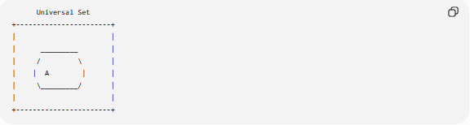
Universal Set
+-----------------------+
| |
| _________ |
| / \ |
| | A | |
| \_________/ |
| |
+-----------------------+
Example with two sets
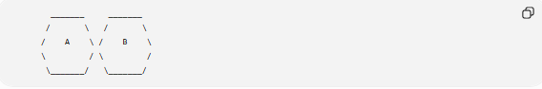
_______ _______
/ \ / \
/ A \ / B \
\ / \ /
\_______/ \_______/
Venn diagrams are useful for studying:
- Union
- Intersection
- Difference
- Complement
# Source: Table Source: Provided by: [Data Path: Persons Table -> ID Column: 1, Name_En Column: Motasem Essam] From: [Data Path: Miscellaneous Folder -> Miscellaneous Database -> Miscellaneous Table -> ID: 45] on [7/7/2026]
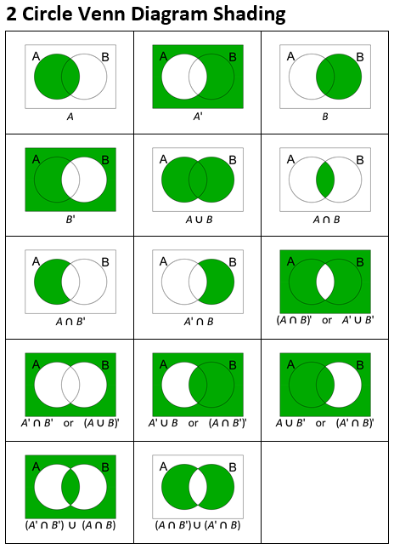
# Source: Table Source: Provided by: [Data Path: Persons Table -> ID Column: 1, Name_En Column: Motasem Essam] From: [Data Path: Miscellaneous Folder -> Miscellaneous Database -> Miscellaneous Table -> ID: 46] on [7/7/2026]
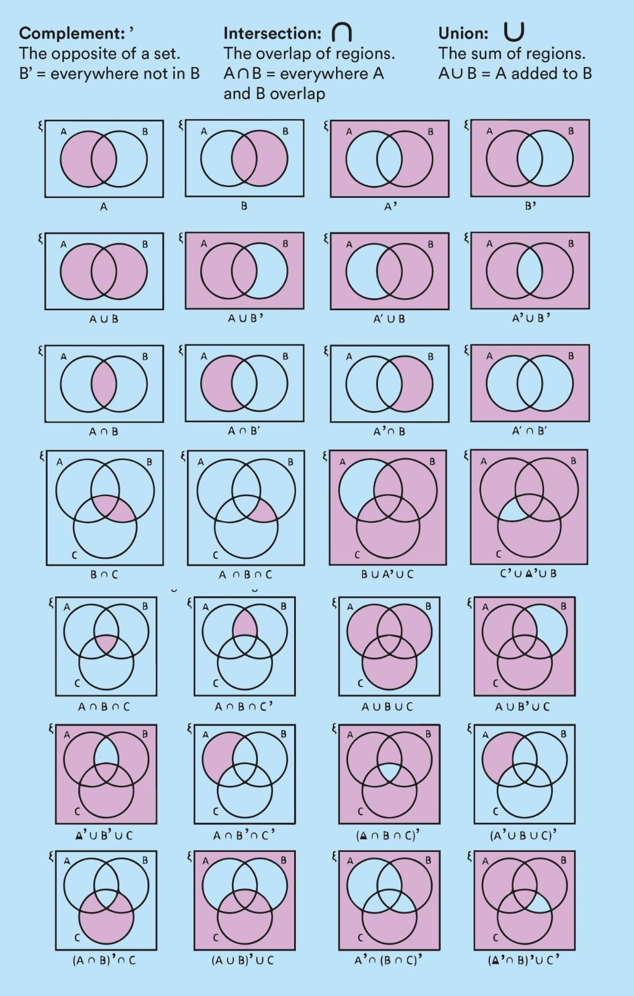

🔢 Numerical Sets
# Source: AI Source: Provided by: [Data Path: Persons Table -> ID Column: 1, Name_En Column: Motasem Essam] -> From: [ChatGPT] on [7/7/2026]
These are the most common sets of numbers.
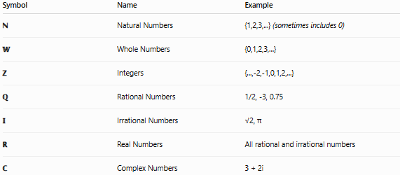
Symbol | Name | Example
ℕ | Natural Numbers | {1,2,3,...} (sometimes includes 0)
𝕎 | Whole Numbers | {0,1,2,3,...}
ℤ | Integers | {...,-2,-1,0,1,2,...}
ℚ | Rational Numbers | 1/2, -3, 0.75
𝕀 | Irrational Numbers | √2, π
ℝ | Real Numbers | All rational and irrational numbers
ℂ | Complex Numbers | 3 + 2i
Hierarchy
ℕ ⊂ 𝕎 ⊂ ℤ ⊂ ℚ ⊂ ℝ ⊂ ℂ

🔢 Common Sets from Integers
# Source: AI Source: Provided by: [Data Path: Persons Table -> ID Column: 1, Name_En Column: Motasem Essam] -> From: [ChatGPT] on [7/7/2026]
Integers (ℤ) can be grouped into many useful subsets based on their properties.
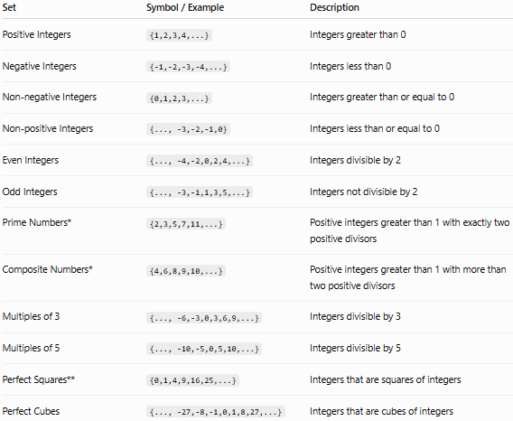
Set | Symbol / Example | Description
Positive Integers | {1,2,3,4,...} | Integers greater than 0
Negative Integers | {-1,-2,-3,-4,...} | Integers less than 0
Non-negative Integers | {0,1,2,3,...} | Integers greater than or equal to 0
Non-positive Integers | {..., -3,-2,-1,0} | Integers less than or equal to 0
Even Integers | {..., -4,-2,0,2,4,...} | Integers divisible by 2
Odd Integers | {..., -3,-1,1,3,5,...} | Integers not divisible by 2
Prime Numbers* | {2,3,5,7,11,...} | Positive integers greater than 1 with exactly two positive divisors
Composite Numbers* | {4,6,8,9,10,...} | Positive integers greater than 1 with more than two positive divisors
Multiples of 3 | {..., -6,-3,0,3,6,9,...} | Integers divisible by 3
Multiples of 5 | {..., -10,-5,0,5,10,...} | Integers divisible by 5
Perfect Squares** | {0,1,4,9,16,25,...} | Integers that are squares of integers
Perfect Cubes | {..., -27,-8,-1,0,1,8,27,...} | Integers that are cubes of integers

🔢 Sets in Real Life
# Source: AI Source: Provided by: [Data Path: Persons Table -> ID Column: 1, Name_En Column: Motasem Essam] -> From: [ChatGPT] on [7/7/2026]
Sets are not just abstract concepts in mathematics; they also play a significant role in various real-life applications. Here are some examples:

Real-Life Examples of Sets
- Shopping Lists
  - Description: A shopping list is essentially a set of items you need to buy.
  - Example: {milk,bread,eggs,butter}
- Classrooms
  - Description: A classroom can be considered a set of students enrolled in a particular class.
  - Example: {Alice,Bob,Charlie,Diana}
- Music Playlists
  - Description: A playlist is a set of songs grouped together for listening.
  - Example: {"Song 1","Song 2","Song 3"}
- Sports Teams
  - Description: A sports team is a set of players selected to play together.
  - Example: {player1,player2,player3,…}
- Library Catalogs
  - Description: A library catalog is a set of books available in the library.
  - Example: {"Book A","Book B","Book C"}
- Family Members
  - Description: A family can be considered a set of people related by blood, marriage, or adoption.
  - Example: {father,mother,son,daughter}
- Travel Itineraries
  - Description: An itinerary is a set of places you plan to visit.
  - Example: {Paris,Rome,Berlin}
- Email Contacts
  - Description: Your list of email contacts is a set of people you can send emails to.
  - Example: {contact1@example.com,contact2@example.com}
- Social Media Friends
  - Description: The people you are connected with on social media form a set.
  - Example: {friend1,friend2,friend3}

Importance of Sets in Real Life
Sets help us organize and categorize information efficiently. They allow us to perform operations such as finding common elements (intersection), combining elements (union), and determining differences (set difference). These operations are fundamental in various fields, including computer science, engineering, data analysis, and everyday decision-making.

Sets are used to organize and classify objects.
Examples
Students
Students = {Ali, Sara, Omar}

Countries
Countries = {Egypt, Japan, Canada}

Programming Languages
Languages = {Python, Java, PHP}

Web Browsers
Browsers = {Chrome, Firefox, Edge, Safari}

API Tools
API Tools = {Postman, Insomnia, cURL}

Databases
Databases = {MySQL, PostgreSQL, MongoDB}

🔢 Set Applications
# Source: AI Source: Provided by: [Data Path: Persons Table -> ID Column: 1, Name_En Column: Motasem Essam] -> From: [ChatGPT] on [7/7/2026]
Set theory is used in many fields.
Mathematics
- Number systems
- Algebra
- Geometry
- Probability

Computer Science
- Databases
- Data structures
- Algorithms
- Artificial Intelligence

Programming
- Collections
- Unique values
- Searching
- Filtering
Example (Python)
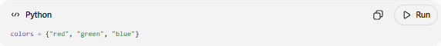
colors = {"red", "green", "blue"}

Database Systems
SQL operations such as:
- UNION
- INTERSECT
- EXCEPT
are based on set theory.

Artificial Intelligence
Used in:
- Knowledge representation
- Machine learning
- Rule-based systems

Data Science
Used for:
- Data filtering
- Classification
- Clustering

Business
Used to:
- Organize customers
- Group products
- Analyze sales

Everyday Life
Examples include:
- Library books
- Sports teams
- School classes
- Shopping lists
- Music playlists
- Contact lists

Sets are fundamental in mathematics and have numerous practical applications in various fields. Here are some examples of how sets are used in real-life scenarios:
Computer Science
- Data Structures: Sets are used to implement data structures like hash sets and binary search trees, which allow efficient storage, retrieval, and manipulation of data.
  - Example: Checking for duplicates in a list can be efficiently performed using a set.
- Database Operations: Sets are essential in relational databases for operations such as UNION, INTERSECTION, and DIFFERENCE, which correspond to SQL commands.
  - Example: Finding common records between two tables.
Mathematics and Logic
- Problem Solving: Sets are used to solve problems involving group theory, number theory, and combinatorics.
  - Example: Venn diagrams illustrate set relationships and help solve probability problems.
- Formal Logic: Sets form the basis of formal logic and help in defining mathematical proofs and functions.
  - Example: Defining the domain and range of a function using sets.
Science and Engineering
- Classification: In biology, sets are used to classify organisms based on shared characteristics.
  - Example: The set of all mammals or the set of all flowering plants.
- Signal Processing: Sets help in filtering and analyzing signals, where specific frequencies or patterns are identified and processed.
  - Example: The set of frequencies in a Fourier transform.
Everyday Life
- Organizing Data: Sets are used to manage and organize data, such as contact lists, shopping lists, and to-do lists.
  - Example: A set of contacts in your phone.
- Surveys and Polls: Sets are used to analyze survey data, where participants' responses can be grouped and compared.
  - Example: The set of people who prefer tea over coffee.
Medicine
- Medical Records: Sets help in organizing and querying patient records based on specific criteria.
  - Example: The set of patients with a particular medical condition.
- Genomics: Sets are used in genomics to group genes and analyze genetic variations and their effects.
  - Example: The set of genes associated with a particular trait or disease.
Marketing and Business
- Customer Segmentation: Sets are used to segment customers into groups based on purchasing behavior and preferences.
  - Example: The set of customers who bought a specific product.
- Market Analysis: Sets help in analyzing market trends and identifying target audiences.
  - Example: The set of products that are trending in a particular season.

🔢 why use set
# Source: AI Source: Provided by: [Data Path: Persons Table -> ID Column: 1, Name_En Column: Motasem Essam] -> From: [ChatGPT] on [7/7/2026]
In set theory, a set is a fundamental concept used to group and organize objects, known as elements. Sets are used because they provide a simple, yet powerful way to represent and analyze collections of objects in a structured manner. Here are some reasons why sets are used in set theory:

1. Foundation of Mathematics
# Source: AI Source: Provided by: [Data Path: Persons Table -> ID Column: 1, Name_En Column: Motasem Essam] -> From: [ChatGPT] on [7/7/2026]
Set theory serves as the foundational language of modern mathematics. Nearly all mathematical structures, including numbers, functions, and geometric objects, can be described using sets.

- Example: The set of natural numbers N={1,2,3,4,… } forms the basis of number theory.

2. Organization and Classification
# Source: AI Source: Provided by: [Data Path: Persons Table -> ID Column: 1, Name_En Column: Motasem Essam] -> From: [ChatGPT] on [7/7/2026]
Sets allow for the systematic classification of objects. By grouping elements with similar properties, sets help organize complex data and simplify analysis.

- Example: The set of colors in a rainbow can be expressed as R={red,orange,yellow,green,blue,indigo,violet}.

3. Defining Relationships
# Source: AI Source: Provided by: [Data Path: Persons Table -> ID Column: 1, Name_En Column: Motasem Essam] -> From: [ChatGPT] on [7/7/2026]
Sets help define relationships between objects, such as:
- Subsets: Identifying elements that belong to multiple groups.
- Intersections: Finding common elements between sets.
- Unions: Combining multiple sets into one.

Examples
- Subsets: If A={1,2} and B={1,2,3,4}, then A⊂B (A is a subset of B).
- Intersections: If X={1,2,3} and Y={2,3,4}, then X∩Y={2,3} (common elements).
- Unions: If X={1,2,3} and Y={2,3,4}, then X∪Y={1,2,3,4} (all unique elements).

4. Logical Reasoning
# Source: AI Source: Provided by: [Data Path: Persons Table -> ID Column: 1, Name_En Column: Motasem Essam] -> From: [ChatGPT] on [7/7/2026]
Sets facilitate logical reasoning through operations like union, intersection, and complement. These operations are used to model logical concepts like "AND," "OR," and "NOT."

- Example: Let A={x∣x is a multiple of 2} and B={x∣x is a multiple of 3}. The intersection A∩B represents multiples of 6.

5. Modeling and Problem Solving
# Source: AI Source: Provided by: [Data Path: Persons Table -> ID Column: 1, Name_En Column: Motasem Essam] -> From: [ChatGPT] on [7/7/2026]
Sets are used to model various real-world problems, such as:
- Grouping items with shared attributes.
- Representing preferences or choices.
- Analyzing survey data.

- Example: In a survey, if 20 students like soccer and 15 like basketball, and 10 like both, we can model this with sets:
- S={students who like soccer}
- B={students who like basketball}
- ∣S∩B∣=10 (students liking both)

6. Building Advanced Structures
# Source: AI Source: Provided by: [Data Path: Persons Table -> ID Column: 1, Name_En Column: Motasem Essam] -> From: [ChatGPT] on [7/7/2026]
Sets are the building blocks of more advanced mathematical structures like:
- Functions (as sets of ordered pairs)
- Relations
- Sequences and series
- Probability spaces
- Example: A function f:A→B can be defined as a set of ordered pairs, like f={(1,a),(2,b),(3,c)}, mapping elements from set A to set B.

7. Handling Infinity
# Source: AI Source: Provided by: [Data Path: Persons Table -> ID Column: 1, Name_En Column: Motasem Essam] -> From: [ChatGPT] on [7/7/2026]
Set theory provides a framework for understanding and analyzing infinite collections, which are essential in higher mathematics.
- Example: The set of real numbers R is infinite and uncountable, while the set of integers Z={…,−2,−1,0,1,2,… } is infinite but countable.

🧠 Simple Analogy
# Source: AI Source: Provided by: [Data Path: Persons Table -> ID Column: 1, Name_En Column: Motasem Essam] -> From: [ChatGPT] on [7/7/2026]
Think of a set as a container or basket.
- The basket is the set.
- The items inside are the elements.
- You can compare baskets, combine them, or find items they have in common.

🧭 Summary
# Source: AI Source: Provided by: [Data Path: Persons Table -> ID Column: 1, Name_En Column: Motasem Essam] -> From: [ChatGPT] on [7/7/2026]
After studying this Topic: Sets, you should understand:
- ✅ What a set is
- ✅ The rules that define a set
- ✅ Different ways to represent sets
- ✅ How to read and draw Venn diagrams
- ✅ Common numerical sets (ℕ, ℤ, ℚ, ℝ, ℂ)
- ✅ How sets appear in everyday life
- ✅ Why set theory is fundamental to mathematics, computer science, databases, programming, and many other fields

